Dahua Dolynk (Cloud ARC) Configuration Guide – GCX-ONE

Disclaimer
This document is provided under NXGEN Technology Ltd's (NXGEN) General Terms & Conditions.
https://www.nxgen.io/en/gtc/

Intellectual Property and Copyright
All content, including but not limited to text, graphics, logos, images, audio clips, and software, available on NXGEN's platforms and services is the intellectual property of NXGEN or its licensors and is protected by copyright laws. Unauthorized reproduction, distribution, or modification of any content without prior written consent from NXGEN is strictly prohibited. Users are granted limited, non-exclusive, and revocable permission to access and use the content for personal or internal business purposes only. Any misuse or infringement of NXGEN's intellectual property rights will be subject to legal action.
https://www.nxgen.io/

Introduction:
This documentation provides a comprehensive overview of the Dahua Dolynk configuration process. Designed to be straightforward and user-friendly, this guide will walk you through each step to ensure a smooth setup. Whether you are new to DahuaDolynk or simply need a refresher, this document will equip you with all the necessary information to configure the system efficiently and effectively.

Prerequisites:
Before configuring the device in GCX-ONE, collect and provide the following information to NXGEN:
- Device Serial Number (SN)
- Username
- Password
Ensure the device is online before proceeding.

1. Configure Device in Dolynk Care
Step 1: Log in to your Dolynk Care account through this URL.
Step 2: Navigate to Site and click Add.
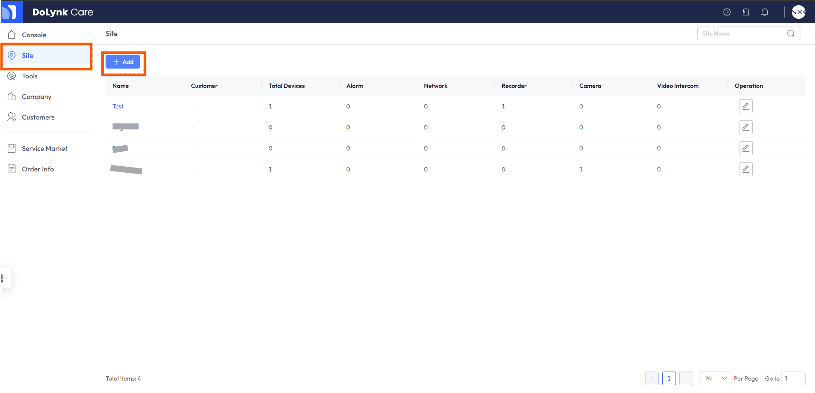

Step 3: Enter the site details (e.g., Time Zone and Name).
Step 4: Open the newly created site and click Add Device via Serial Number (SN). Enter the required device details.
Note: Ensure the device is online before adding it.

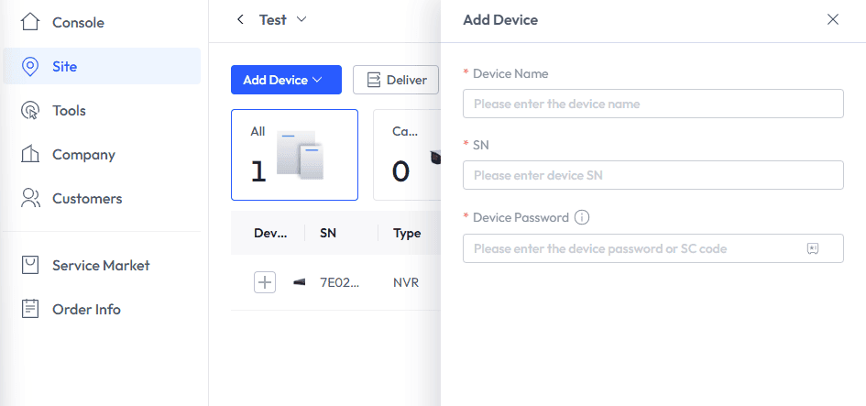

Step 5: Now that the device is added to your Dolynk Care account, we need to set up GCX-ONE as your ARC (Alarm Receiving Center) for that device by selecting the Security Service option as per Screenshot:

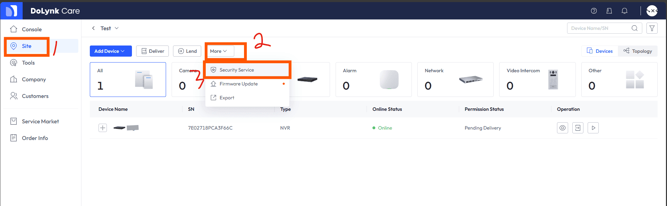

Step 6: In the menu that shows, select the device/sensors that you want to share with GCX-ONE then click on Next, in the Company Name/email field please use our email to search (dev@nxgen.info), once that is done, you should see NXGEN Technology AG, click on the shield icon next to it, please note that your request will be automatically approved

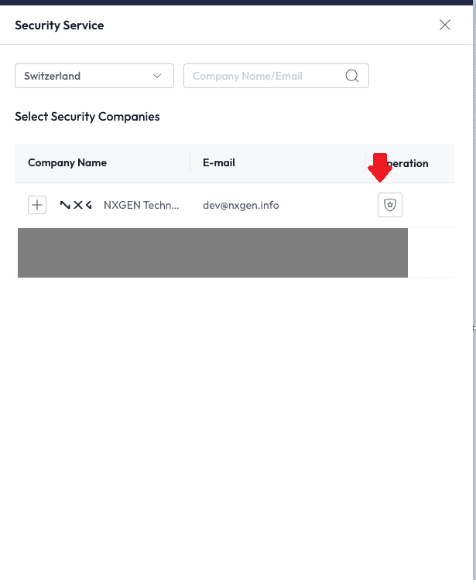

Step 7: Click on Apply to save and notify your ARC.
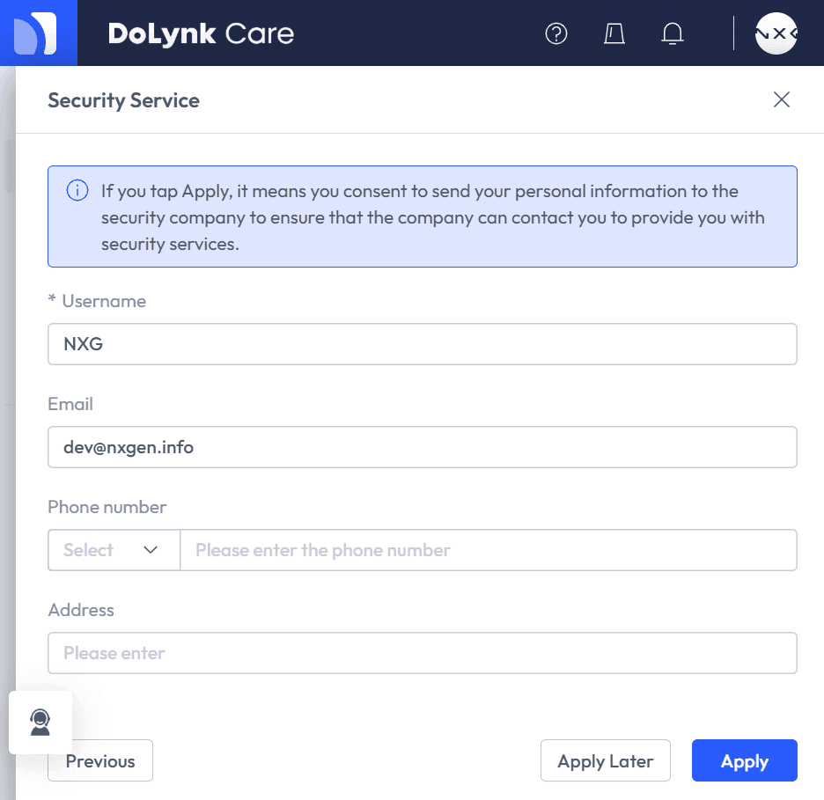

2. Add Dahua Dolynk (Cloud ARC) in GCX-ONE
Step 1: Log in to GCX-ONE.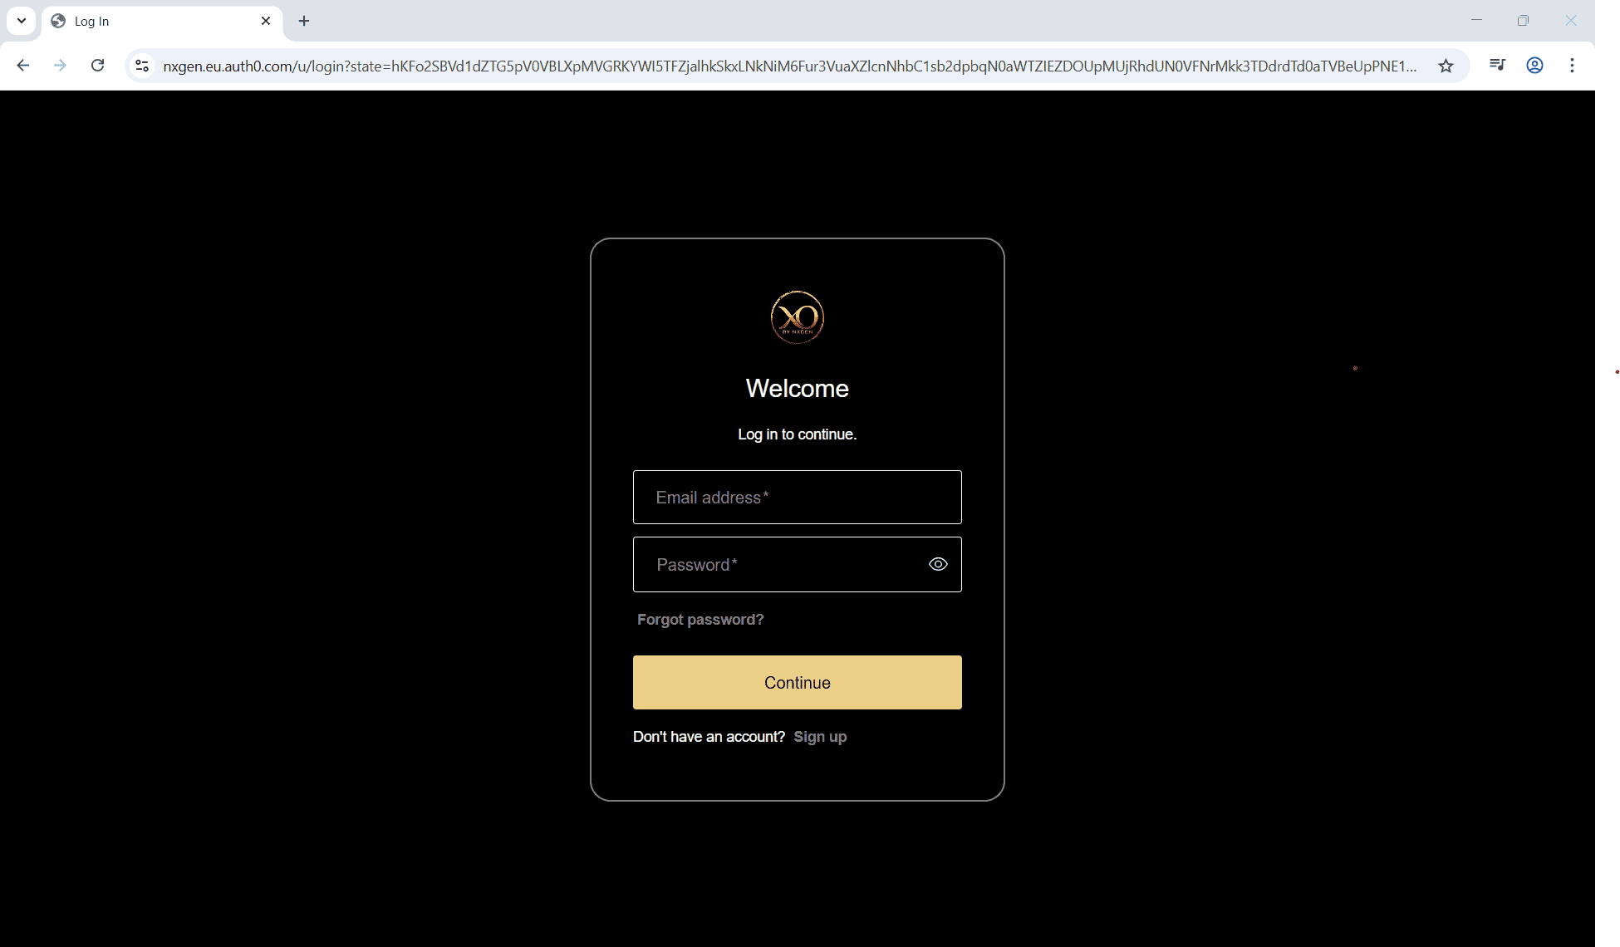
Step 2: Click on the Configuration menu.
Step 3: At the Service Provider level, click on Customers.
Step 4: Click the Add button.
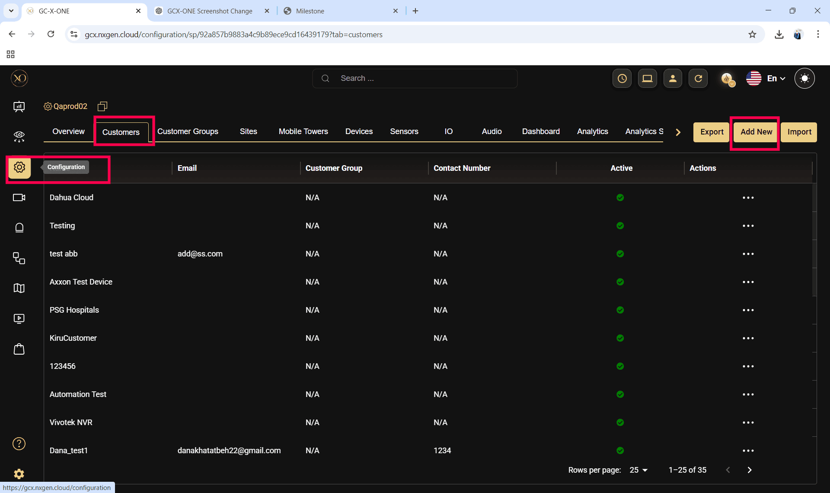

Step 5: Enter the required fields and click Save.
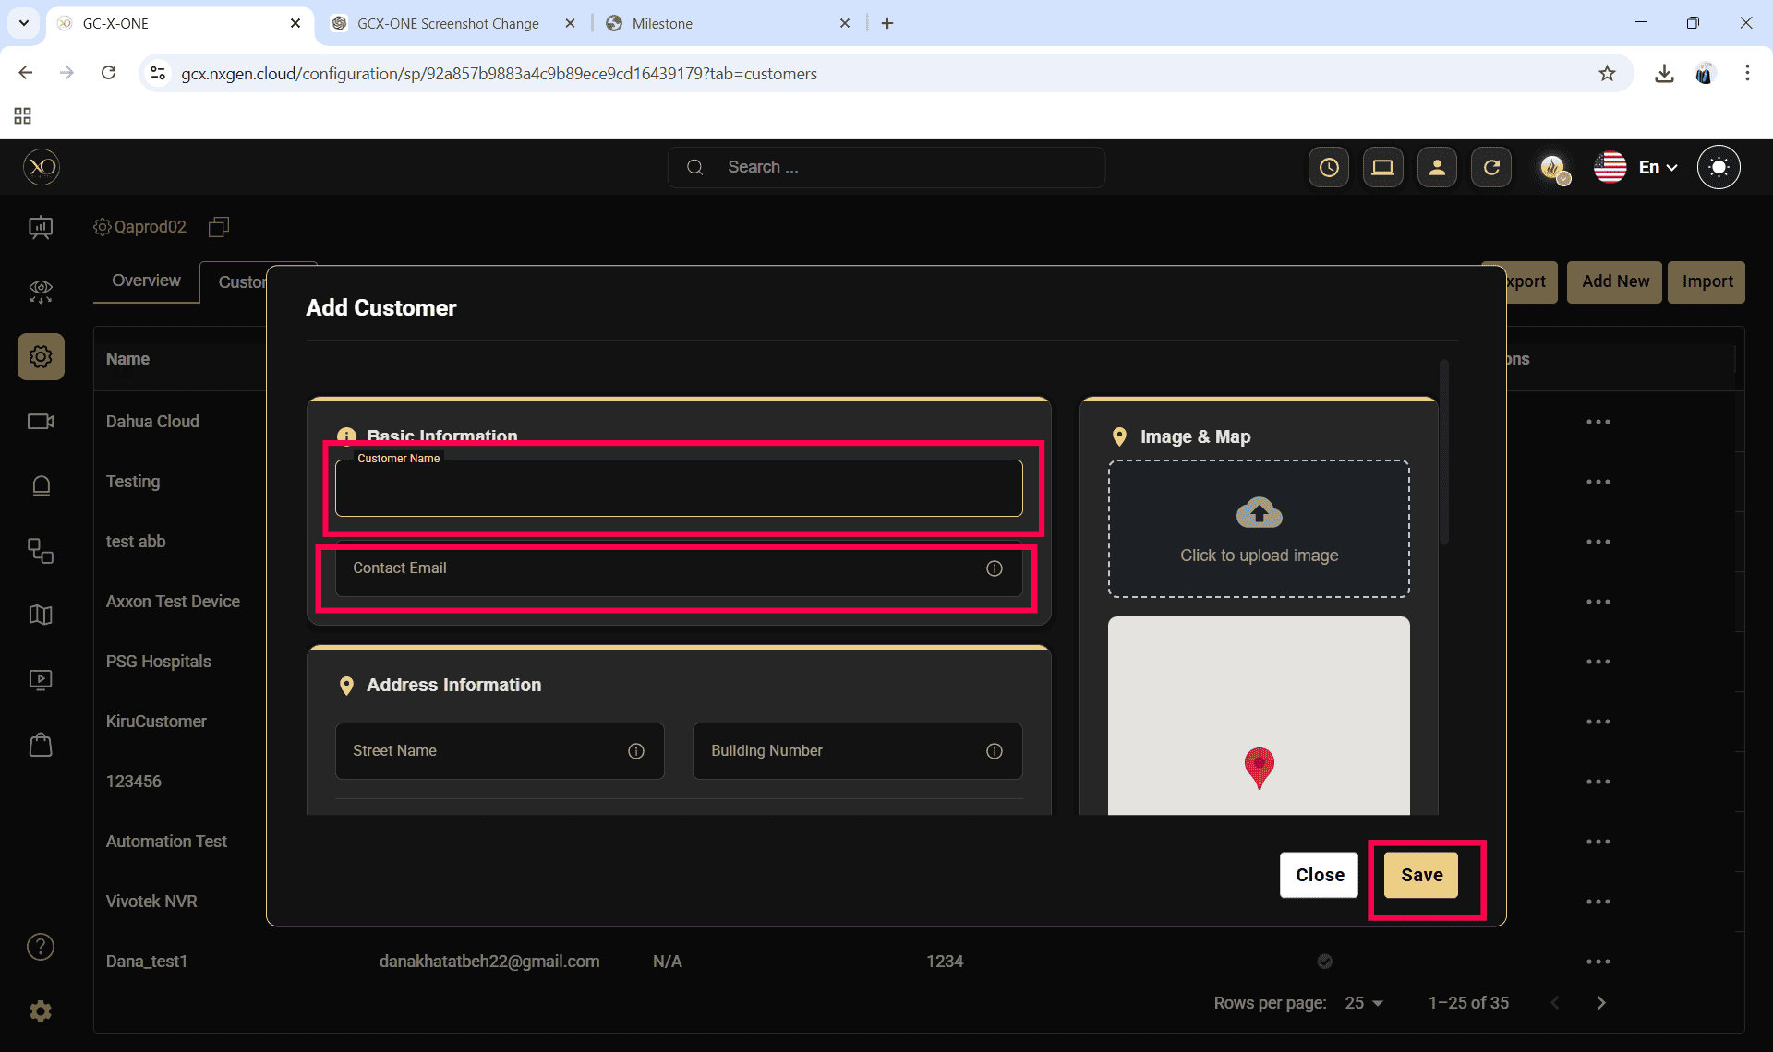
Step 6: Select the newly created customer.
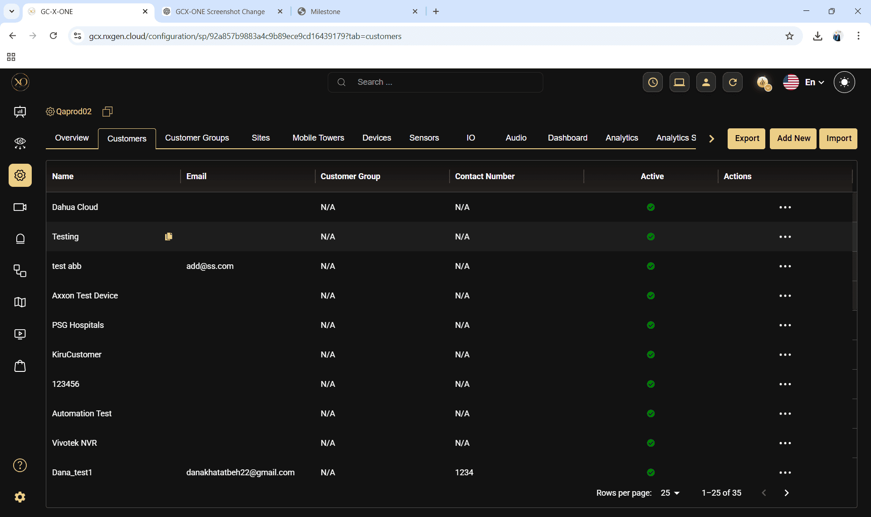
Step 7: Navigate to the Sites tab.
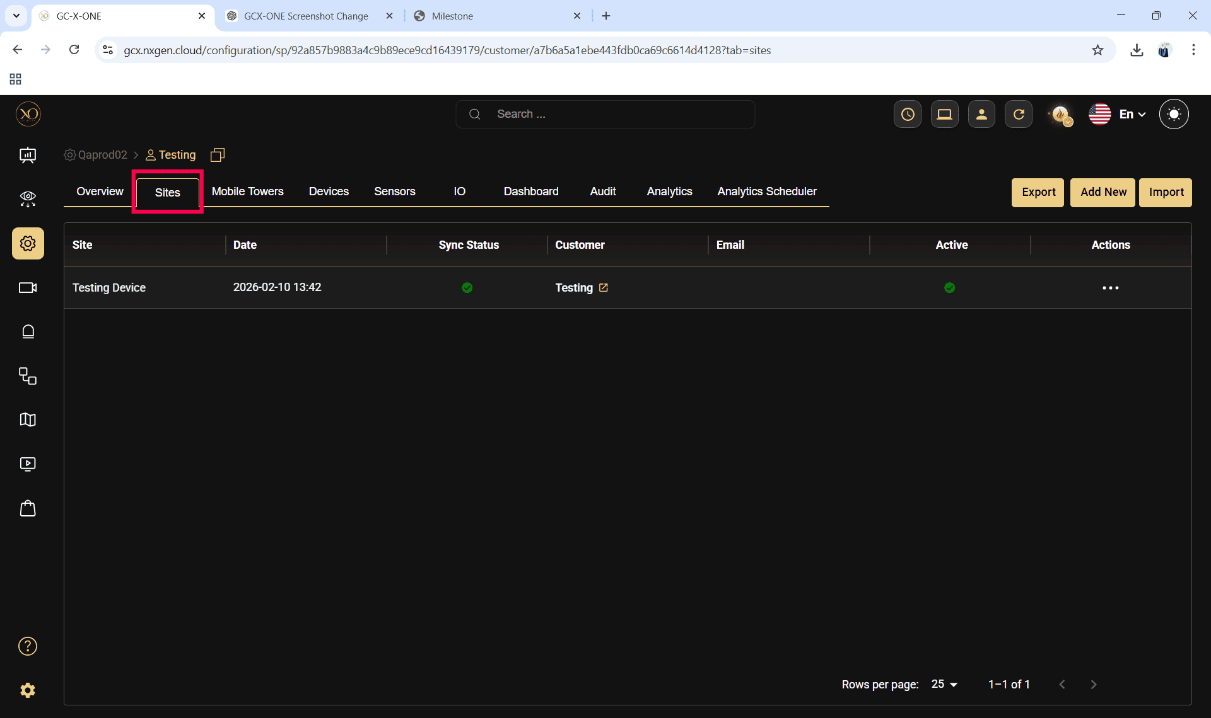
Step 8: Click the Add button.
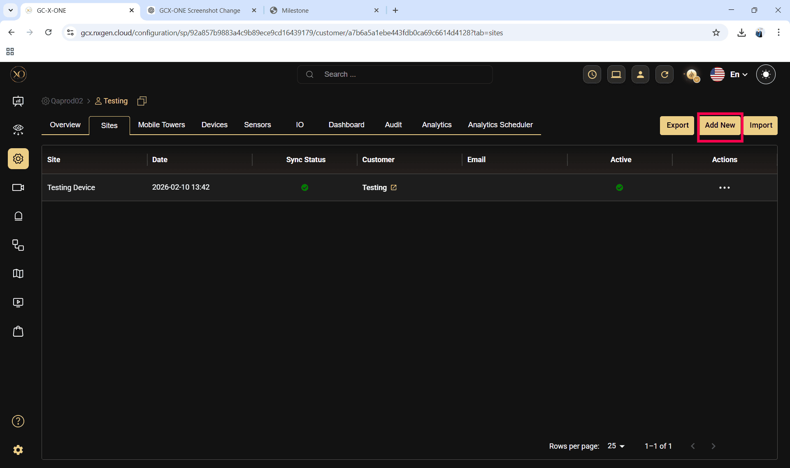

Step 9: Enter the required fields and click Save.
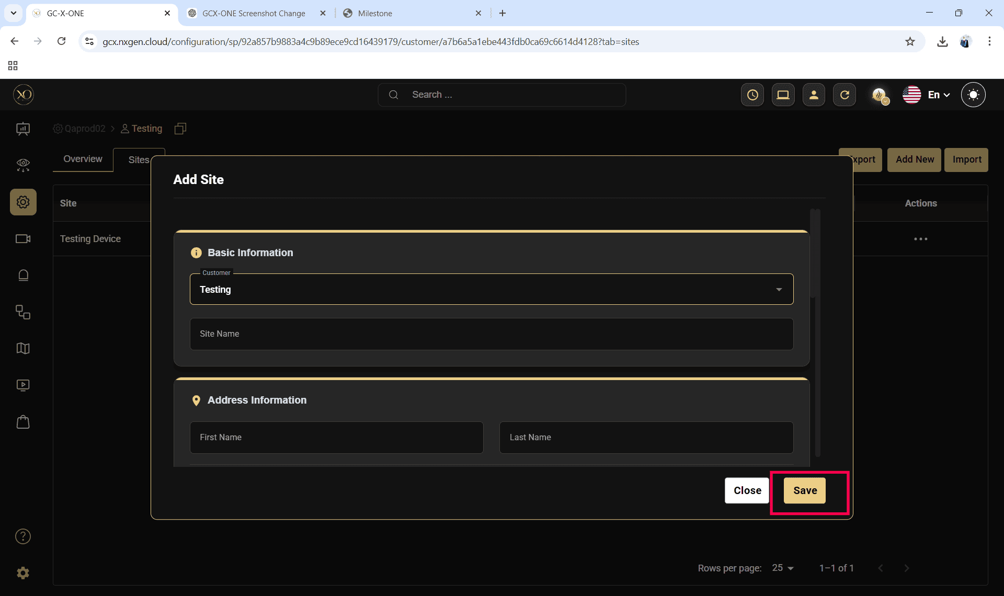

Step 10: Select the newly created site.
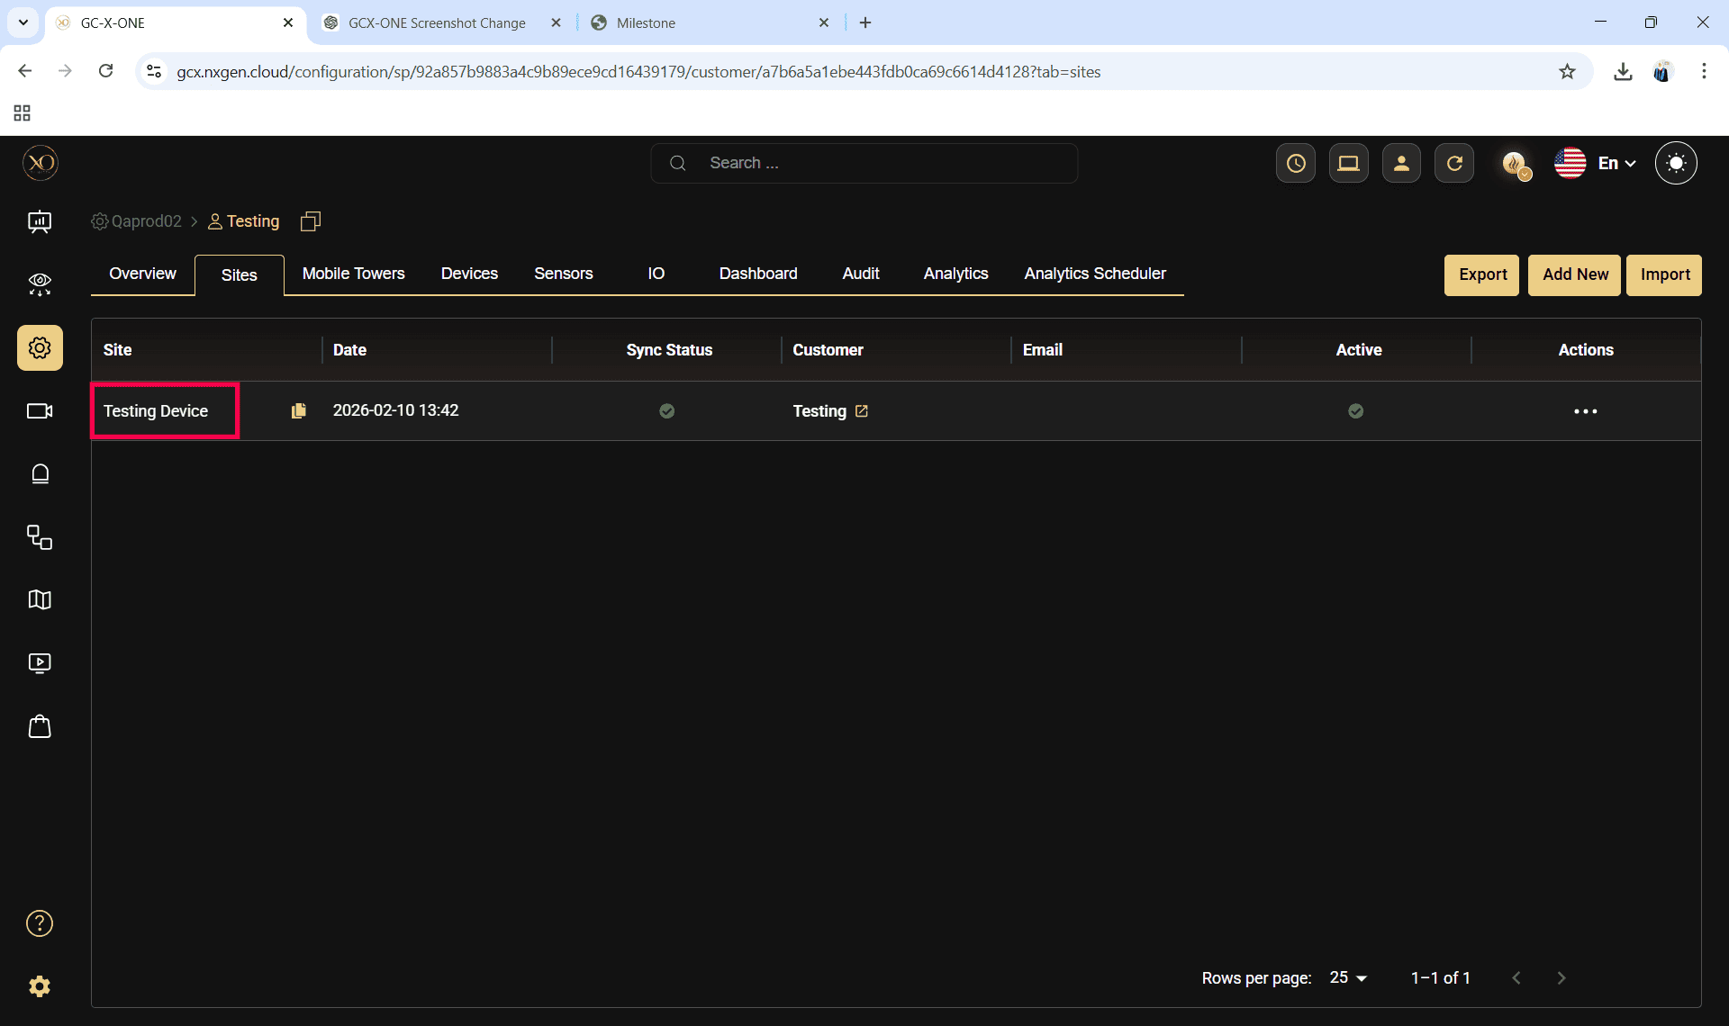

Step 11: Navigate to the Devices tab.
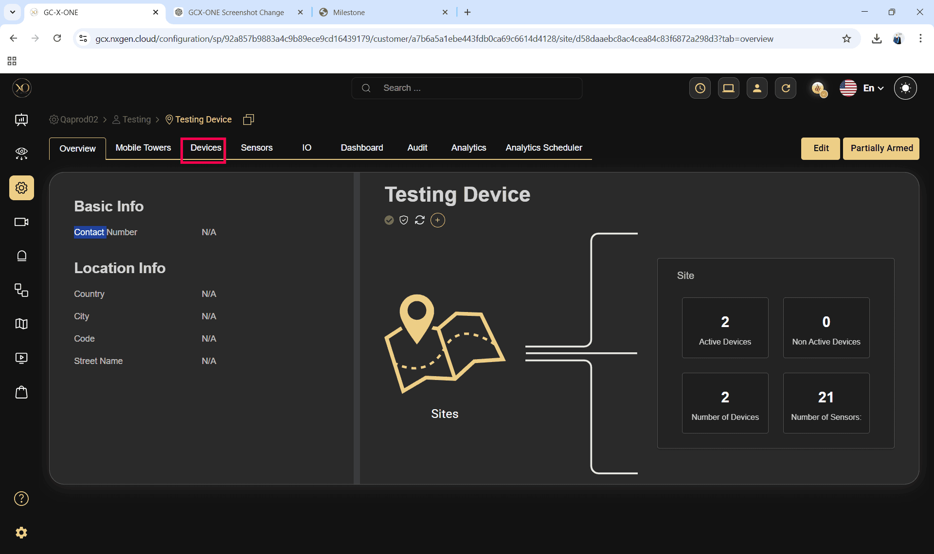
Step 12: Click the Add button.
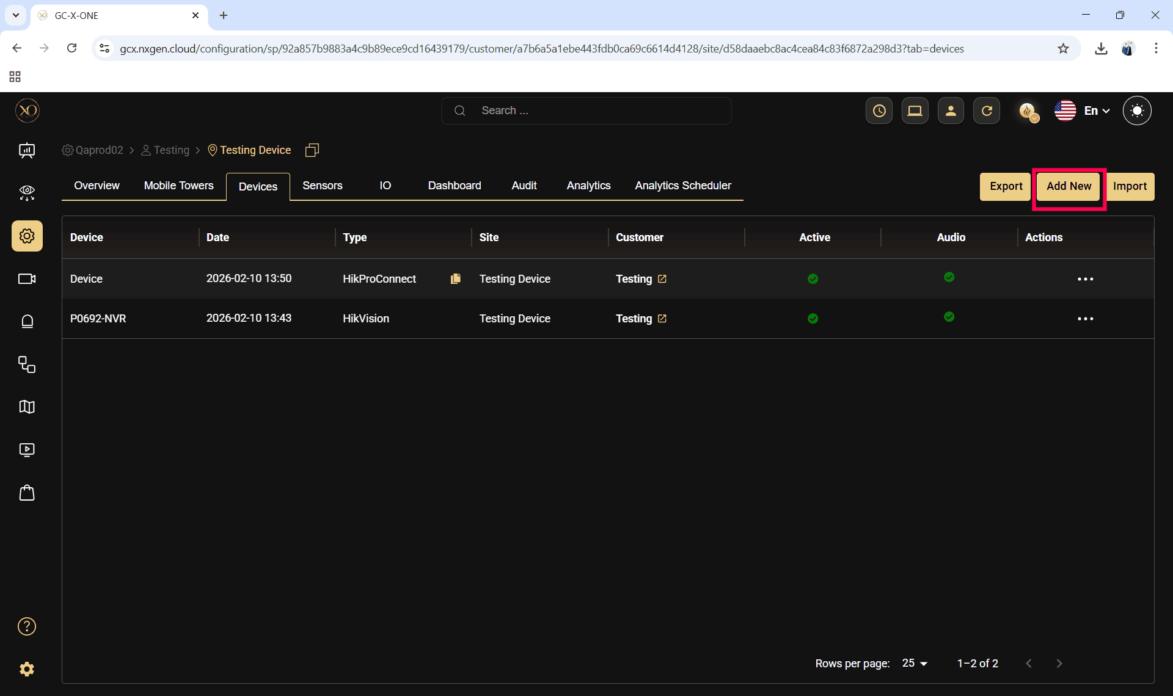

Step 13: The Add Device dialog will be displayed.
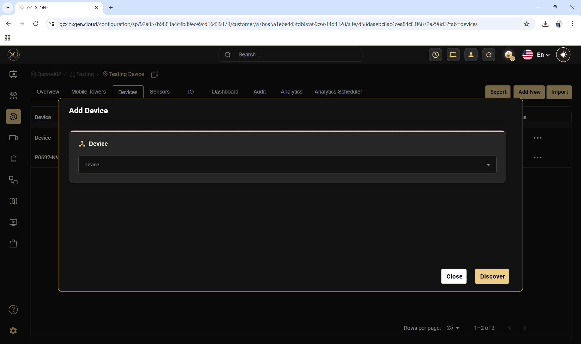

Step 14: In the dialog, open the Device dropdown and select DahuaCloudArc

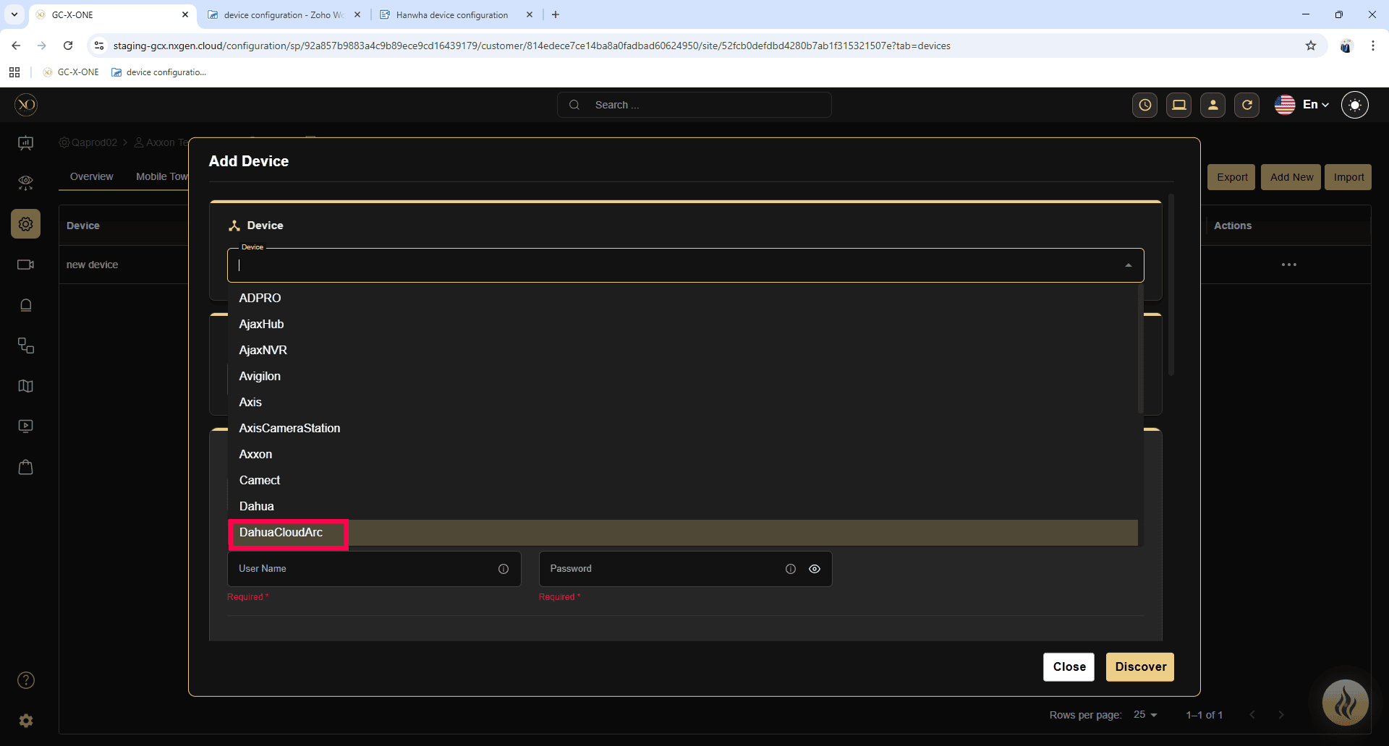

Step 15: Enter all required fields:
- Name
- Serial number
- User name
- Password
- Timezone

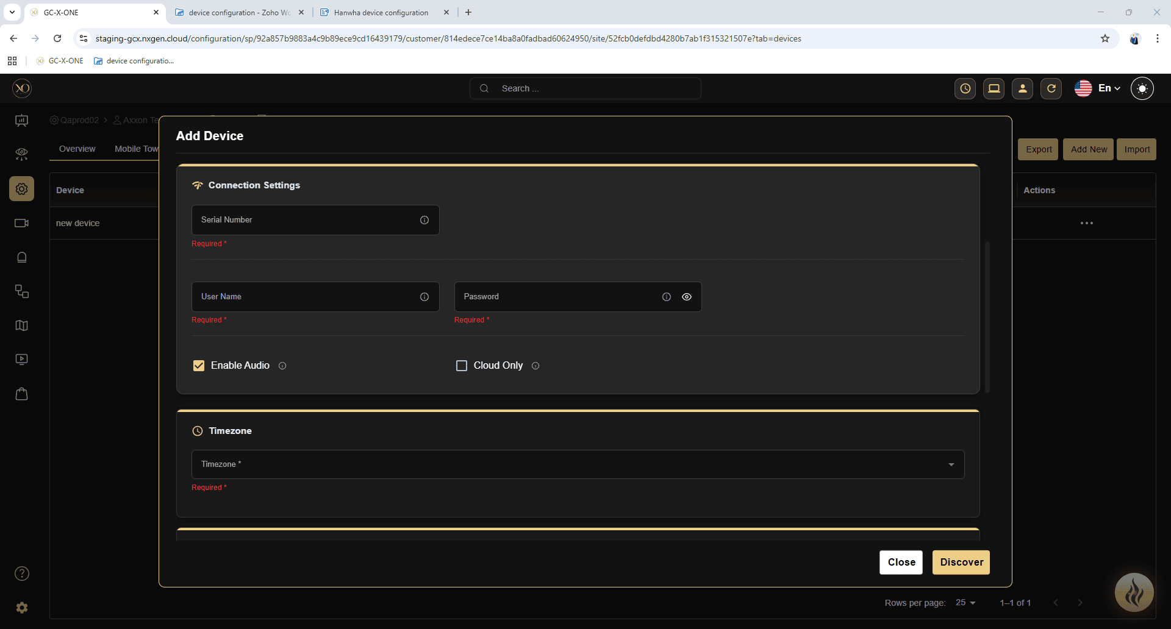

Step 16: Click Discover.
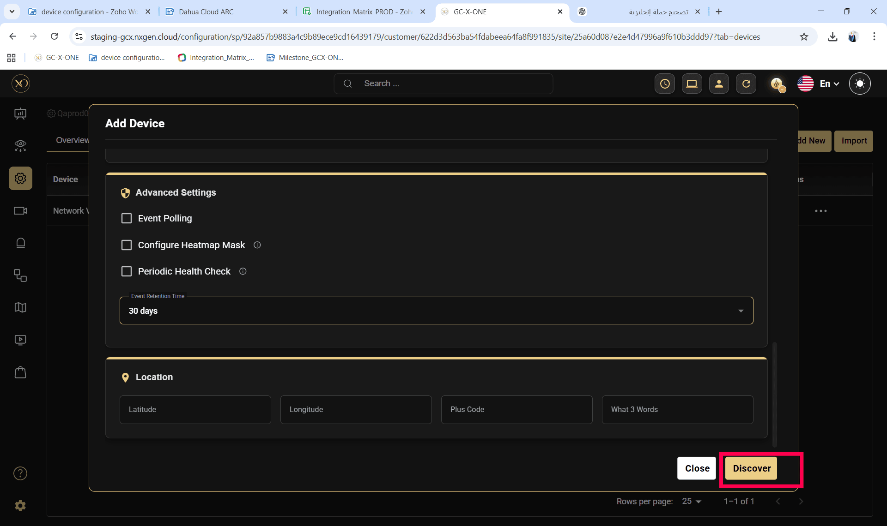

Step 17: Once the device is successfully discovered, click Save.

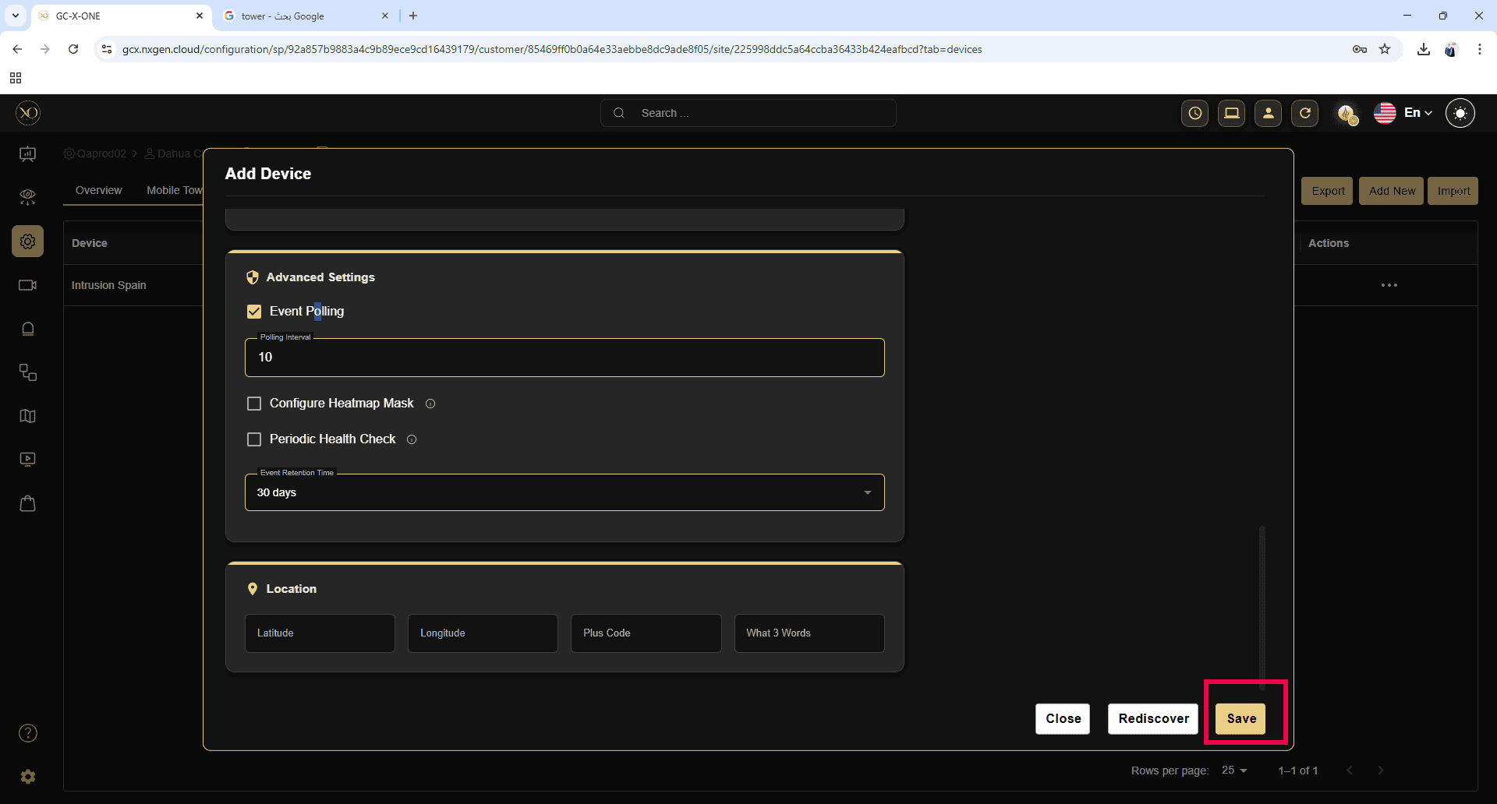
These steps and explanations will help you configure the DahuaDolynk device into GCX-ONE.
If any issues arise with the configuration, please raise a ticket on NXGEN's Help-desk portal to the NXGEN support team for swift issue resolution.

